Network Manager

Release Notes v4.3.0.0 Fix 7

Lateral Offsets for Norfolk C.C.

Introduction

This document defines the changes made to the Network Manager product for fix release v4.3.0.0 Fix 7 and is specifically targeted at Norfolk County Council. This fix is not suitable for any other customers.

After reading through this document, should you have any further training or consultancy requirements then please contact your ***exor*** account manager.

Scope of Changes

The changes outlined in this document are those that will enable Norfolk County Council to generate and maintain spatial representations of assets by dynamic segmentation and use of a lateral offset driven by Cross-Sectional-Position or XSP.

The document is divided into three parts, the first part is related to the software changes and supporting metadata structure and the second part describes the process of the XSP validation and the migration of new data. The third part relates to the bugs that have been addressed as part of this fix release.

The availability of lateral offsets is based on a new system option called XSPOFFSET and when set to Y the user may set the flag to use lateral offsets in the layer creation tool. The default of this value is set to N and hence lateral offsets will be disabled.

Fix Details

| **Baseline Release** | 4.3.0.0 |
| --- | --- |
| **Fix Description** | Provide lateral offsets in dyn-segged spatial data for Norfolk CC |
| **Prerequisites** | Code should be at the standard 4.3 release version |
| **Implementation Instructions** | Unzip nm_4300_fix7.zip to a staging folder.  Go to the relevant exor\bin directory on the Oracle Application Server and rename the following files:-  gis0020.fmx to gis0020_old.fmx  nm0305.fmx to nm0305_old.fmx  Then copy in the new versions of these files from the staging folder.  Log onto SQL*PLUS as the Highways Owner with the staging folder as the working directory.  At the prompt type “START nm_4300_fix7.sql” and press return.  Exit SQL*PLUS. |
| **Limitations** | None known |
| **Configuration Information** | None |
| **How To Test** | Recommend full regression test |
| **Rollback Strategy** | Set the product option to ignore the lateral offset |

List of Amended Files

| **Filename** | **Version** |
| --- | --- |
| gis0020.fmx (Norfolk Specific) | 3.3 |
| nm0305.fmx (Norfolk Specific) | 3.0 |
| XSPOFFSET metadata.sql | 3.0 |
| herm_xsp.sql | 3.3 |
| ins_nm_members.trg | 3.4 |
| nm3invval.pkw (Norfolk Spec) | 3.0 |
| nm3merge.pkw (Norfolk Spec) | 3.2 |
| nm3reclass.pkw (Norfolk Spec) | 3.2 |
| nm3replace.pkw (Norfolk Spec) | 3.5 |
| nm3sdm.pkw (Norfolk Spec) | 3.3 |
| nm3sdo.pkw (Norfolk Spec) | 3.4 |
| nm3sdo_dynseg.pkh | 3.4 |
| nm3sdo_dynseg.pkw | 3.4 |
| nm3split.pkw (Norfolk Spec) | 3.4 |
| nm3undo.pkw (Norfolk Spec) | 3.4 |
| nm_inv_items_all_xsp_shape.trg | 3.0 |
| nm_4300_fix7.sql | 3.3 |
| xncc_herm_xsp.pkh | 3.4 |
| xncc_herm_xsp.pkw | 3.8 |
| xncc_refresh_offsets.trg | 3.2 |
| xsp_restraints.vw (Norfolk Spec) | 3.0 |
| xsp_reversal.vw (Norfolk Spec) | 3.0 |

Software and Metadata Changes

Introduction

The original contract for the provision of a network and asset maintenance system included the requirement to deliver a solution to display spatial representations of assets at a lateral offset to the road centre-line. It was proposed that the Cross-Sectional-Position would be used to provide the distance an asset was located off the centreline of the network.

The product does not cater for this generically. This is due to the server code API failing to keep track or to store the original linear object to which the asset location was referenced. This means that the system cannot guarantee the side of the network datum centreline on which the asset is located.

However, a solution can be found that is specific to Norfolk County Council whose recording of XSP is wholly relative to the HERMIS section, a route type that is specific to them. This solution depends on the ability to predict a singular XSP and offset value for each network datum (ESU) at any date. Necessary and sufficient conditions to apply this assumption are:

* All assets are located by reference to a route of a specific type (HERMIS section).
* This route type is a whole-element exclusive route type.
* Route type is mandatory (all datums must be included in this route type)
* In cases whereby the route direction has changed in a single day, the lateral offset of the asset is deemed to be that calculated at the later of the two possible outcomes.
* All offsets are deemed to be in Metres.

These pre-requisites are in line with the business rules of Norfolk County Council and were agreed in a meeting in November 2010.

Background Data

To speed-up access to the lateral offset value, the system is designed to hold the offset values for each XSP on every datum over a range of dates. These offsets are also designed to be controlled by reference to a section-class or sub-classification of the road network. This is a specific column on the network table NE_SUB_CLASS. This de-normalised data will be used to compute the offsets to the centreline and must be kept in-sync with the HERMIS member data. It was agreed that in cases where XSP metadata is to be changed, the user would be expected to re-generate the offsets and refresh the spatial representations of affected themes.

On installation of this patch, the new table (HERM_XSP) will be created. After completion of the installation of the patch, a new package XNCC_HERM_XSP is created. This can be used to perform the process to compute all the XSP offsets. It pre0-supposes that the XSP offset value is populated (in metres) in the NWX_OFFSET column of the NM_NW_XSP table. This procedure call should be performed once through SQL*Plus or some other Oracle client such as TOAD or SQL Developer.

Execute XNCC_HERM_XSP. ins_herm_xsp;

This procedure call must be made by the highways owner. The table is an index-organised-table (IOT) and is used to translate an ESU, XSP combination for a specific section class and date range into a numeric offset in metres.

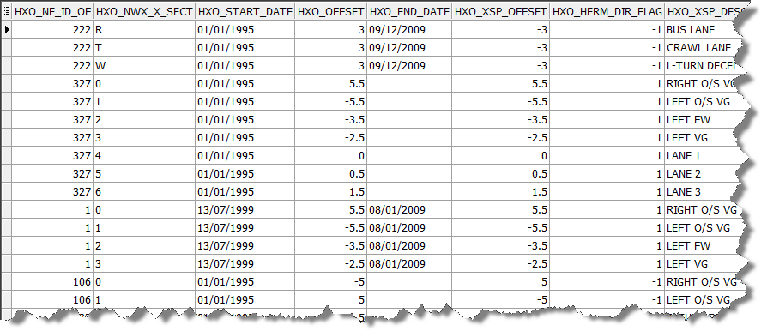

Changes to Network Modules

The data that is held in the HERM_XSP table must be maintained through a variety of network operations. These include all modules that will generate new ESUs, modules that affect the XSP of an asset or the membership of the HERMIS section. The list of modules also affects the undo functions. Also included is the update to XSP from SM and from forms. Changes also include the update of the direction of the ESU relative to the HERMIS section.

| **Module** | **Functionality changes** |
| --- | --- |
| Generate layer | Must allow the user to indicate if the spatial representation is to be based on an XSP offset. This should only be appropriate on themes that represent assets that have been enabled to hold an XSP. Once generated, the shapes should be offset from the centreline based on the herm_xsp table data. The theme XSP column should be set to IIT_X_SECT. |
| Refresh Layer | This process must read the theme xsp-offset column and if set, should regenerate the layer with the lateral offsets. If the column is unset, the system should default to the shape being co-incident with the centreline. |
| Replace | Replace datum should regenerate asset spatial representations on the new datum at the required offset for all theses that have an xsp column set. This function should store the history of the original data prior to the replace. New datums must be created with the offsets in the HERM_XSP table |
| Reclassify element | This will allow the user to change the HERMIS section. Spatial data should be left in an accurate state after execution. |
| Reshape datum | As replace but with no history – however, this will not apply to Norfolk as NSG data always defaults to having history for a reshape (ie reshape with replace) |
| Close datum | Background data in herm_xsp must also be closed as should all asset shapes with or without the offset. |
| Split | New datums should be created in the HEMR_XSP table and carry offsets inherited from the original data. Asset shapes for layers that carry an XSP column value should be regenerated against the new datums with the appropriate lateral offset. |
| Merge | As above but with a singular new ESU |
| Undo | Remove all traces of asset spatial data on the resultant network that is to be undone. Also remove any herm_xsp records |
| Reverse HERMIS | Allow a Hermis section to be reversed. This function will leave asset data unchanged but the cardinality flag will be modified. This change should be included in the herm_xsp table and asset spatial representations should be modified accordingly. |
| Execute Reverse from SM | This function allows the user to hive assets relative to a route and also to relocate asset data after setting the cardinality flags. This should re-locate asset shapes as a transposed shape both in the lateral and longitudinal direction. |

Changes to XSP values of assets

Validation of the asset XSP from Spatial manager has never worked with the Norfolk metadata. Various ECDM logs have been raised on the subject and a single task exists as an umbrella to cover all the logs. In short, the original data had been migrated into tables in an invalid and relationally incorrect state. The changes to the metadata have been addressed and only valid metadata has been inserted. Faults caused by the migration of metadata which related the ESU network to a sub-class were faulty as the ESU attribution does not support the sub-class. Complex views will now perform the translation of valid section classes and XSP combinations from route level down to the ESU datum level. Once the views have been reconfigured the forms and server validation work as expected. Unfortunately, at the time of going to press, the data had been corrected on a development schema but SM failed to validate the XSP data on retrieval of asset attributes and failed to provide the user with a list of valid values. A workaround exists for this until such time that the Spatial Manager code has been changed.

Changes to XSP offsets and metadata re-structuring

If the user wishes to make changes to XSP data by re-structuring the sub-class data or just by adding a new set of XSP values and offsets, the user is required to complete this upgrade and then they must drop and recreate the HERM_XSP records. This would then necessitate the refresh process on every layer that had an inherited XSP. Offsets for each XSP can be entered from the form. See chapter on XSP updates.

This development process has included the re-migration of section-class and XSP combinations for HERMIS data. This software and the ability to perform this upgrade will be handed over to services colleagues who will execute the upgrade at a time that is convenient. Validation scripts will be provided that will perform validation on existing data.

Resultant Data

After dropping the layer representing longitudinal line markings (asset type LL) and re-creating it using the setting on the GIS layers form, the spatial data is offset as shown below.

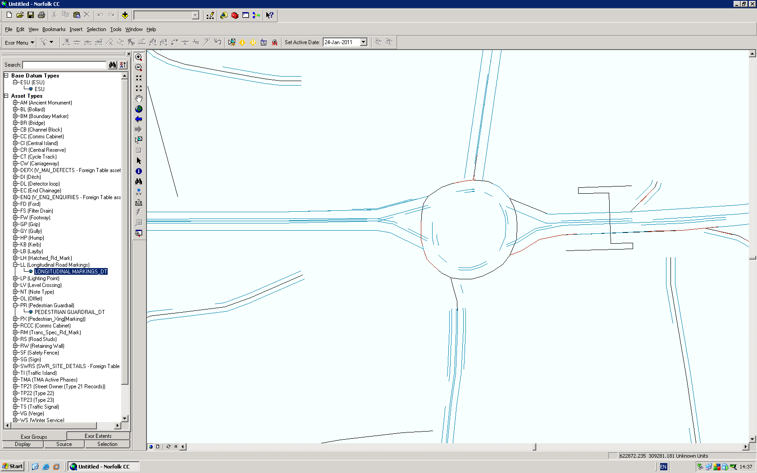

Offsets and over/undershoots

The spatial data is generated from an offset to the spatial representation of the ESU. This means that an asset spanning a vertex at a node between two ESUs could have overshoots or undershoots depending on the data and whether the asset is offset internally or externally to the nodal vertex elbow as shown below.

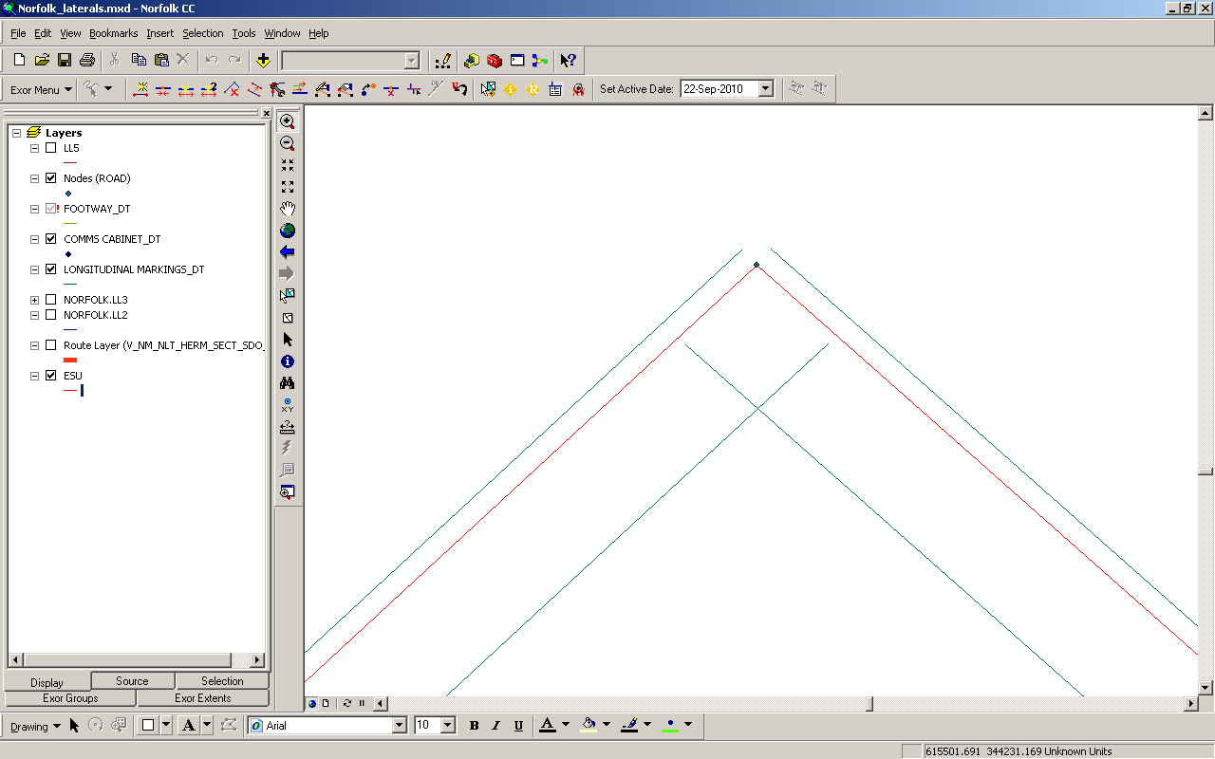

Changes to XSP Data

The following spread-sheet showing XSP data and how it related to new values of sub-class definitions was supplied by Norfolk CC. This data has no real impact on the asset XSP other than to check the validation for those XSPs that are invalid under this new regime of data. Checker scripts have been provided and the customer is at an advanced stage of repairing the data. All scripts will be handed to services colleagues for inclusion after the upgrade to release 4.3.0.0.

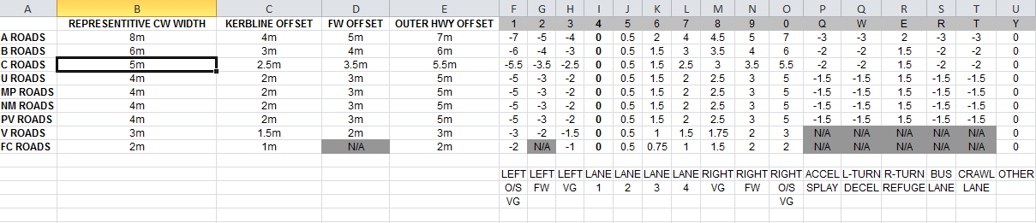

Scripts will be supplied with which the new data is imported into temporary tables and the old asset XSP values will be matched against the new sub-class values originating from the section class flexible attribute associated to the HERMIS section.

Data will be migrated into base tables NM_NW_XSP, NM_XSP_RESTRAINTS and NM_XSP_REVERSAL and new views will be generated to translate the data to the ESU datum layer. The views are provided below for reference. These do not form part of the upgrade for lateral offsets but without them, the system will prevent update to the XSP values of assets, something that will be part of the system acceptance criteria.

View Definitions

**NM_XSP**

The NM_XSP view replaced the base table some time ago but was shipped as a direct copy of the table data. This was never intended. It provides the list of available XSPs on a network. By performing the union of data from sources at the datum and route levels, the user will have the flexibility to work at either level.

CREATE OR REPLACE FORCE VIEW.NM_XSP

(

NWX_NW_TYPE,

NWX_X_SECT,

NWX_NSC_SUB_CLASS,

NWX_DESCR,

NWX_SEQ,

NWX_OFFSET,

NWX_DATE_CREATED,

NWX_DATE_MODIFIED,

NWX_MODIFIED_BY,

NWX_CREATED_BY

)

AS

SELECT nwx_nw_type,

nwx_x_sect,

nwx_nsc_sub_class,

NWX_DESCR,

NWX_SEQ,

NWX_OFFSET,

NWX_DATE_CREATED,

NWX_DATE_MODIFIED,

NWX_MODIFIED_BY,

NWX_CREATED_BY

FROM nm_nw_xsp

UNION

SELECT nng_nt_type,

nwx_x_sect,

nwx_nsc_sub_class,

NWX_DESCR,

NWX_SEQ,

NWX_OFFSET,

NWX_DATE_CREATED,

NWX_DATE_MODIFIED,

NWX_MODIFIED_BY,

NWX_CREATED_BY

FROM nm_nw_xsp, nm_nt_groupings, nm_group_types

WHERE ngt_group_type = nng_group_type AND ngt_nt_type = nwx_nw_type;

**XSP_RESTRAINTS**

Again, the XSP_RESTRAINTS view replaces the original table of the same name but has been shipped as a simple query from the base table. Again, by forming the union across the route and datum types the data can be used to allow the restrictions of assets at route or datum levels. The extra union which provides a dummy asset type of $$ is used to support MAI applications such as DEFECTS.

CREATE OR REPLACE FORCE VIEW XSP_RESTRAINTS

(

XSR_NW_TYPE,

XSR_ITY_INV_CODE,

XSR_SCL_CLASS,

XSR_X_SECT_VALUE,

XSR_DESCR,

XSR_DATE_CREATED,

XSR_DATE_MODIFIED,

XSR_MODIFIED_BY,

XSR_CREATED_BY

)

AS

SELECT "XSR_NW_TYPE",

"XSR_ITY_INV_CODE",

"XSR_SCL_CLASS",

"XSR_X_SECT_VALUE",

"XSR_DESCR",

"XSR_DATE_CREATED",

"XSR_DATE_MODIFIED",

"XSR_MODIFIED_BY",

"XSR_CREATED_BY"

FROM nm_xsp_restraints

UNION ALL

SELECT nng_nt_type,

xsr_ity_inv_code,

nsc_sub_class,

xsr_x_sect_value,

xsr_descr,

xsr_date_created,

xsr_date_modified,

xsr_modified_by,

xsr_created_by

FROM nm_nt_groupings,

nm_xsp_restraints,

nm_group_types,

nm_type_subclass

WHERE xsr_nw_type = ngt_nt_type

AND ngt_group_type = nng_group_type

AND nsc_nw_type = ngt_nt_type

AND nsc_sub_class = xsr_scl_class

UNION ALL

SELECT nwx_nw_type,

'$$',

nwx_nsc_sub_class,

nwx_x_sect,

nwx_descr,

NULL,

NULL,

NULL,

NULL

FROM nm_xsp;

**XSP_REVERSAL**

XSP_REVERSAL is shipped as a simple select from nm_xsp_reversal. Again by imposing the union of data at the datum and group levels, the full set of data is populated at both levels from relationally correct data constructed in the tables.

CREATE OR REPLACE FORCE VIEW XSP_REVERSAL

(

XRV_NW_TYPE,

XRV_OLD_SUB_CLASS,

XRV_OLD_XSP,

XRV_NEW_SUB_CLASS,

XRV_NEW_XSP,

XRV_MANUAL_OVERRIDE,

XRV_DEFAULT_XSP

)

AS

SELECT XRV_NW_TYPE,

XRV_OLD_SUB_CLASS,

XRV_OLD_XSP,

XRV_NEW_SUB_CLASS,

XRV_NEW_XSP,

XRV_MANUAL_OVERRIDE,

XRV_DEFAULT_XSP

FROM nm_xsp_reversal

UNION ALL

SELECT nng_nt_type,

XRV_OLD_SUB_CLASS,

XRV_OLD_XSP,

XRV_NEW_SUB_CLASS,

XRV_NEW_XSP,

XRV_MANUAL_OVERRIDE,

XRV_DEFAULT_XSP

FROM nm_nt_groupings, nm_xsp_reversal, nm_group_types

WHERE xrv_nw_type = ngt_nt_type AND ngt_group_type = nng_group_type;

Spatial Manager and XSP updates

Spatial Manager will expect to perform validation on XSP values by matching the sub-class on existing network locations. This will fail. Until such time that the Spatial Manager code is changed to accommodate a relationally correct metamodel for XSPs, the system can be corrupted to allow it to work. The network sub-classes will need to be added for the ESU data. The script to add this data and reverse it out when required is shown below. Forms data will be able to be modified without these changes. This information is correct in relation to Spatial Manager revision 3.13.

insert into nm_type_subclass

select 'ESU', nsc_sub_class, nsc_descr, nsc_seq_no

from nm_type_subclass

where nsc_nw_type = 'HERM';

delete from nm_type_subclass where nsc_nw_type = 'ESU';

By changing XSP data , the user is performing an error correction to the asset – no history of XSP is available. The user will be able to set the XSP value conditional on the XSP_RESTRAINTS view and will result in a different lateral offset for the asset shape. The new position will depend on the offsets in the HERM_XSP table.

Log No. Summary

This chapter summarises all software changes that have been made in this release.

These changes are derived from the following sources,

* Issues raised by Customers via Exor Support
* Issues raised internally by Exor

**Issues**

|  |  |  |
| --- | --- | --- |
| **Internal**  **Task ID** | **Issue** | **Support**  **Log(s)** |
| 0107982 | Various XSP related bugs all handled by the single task. See the chapter on XSP metamodel for details. Note this does not relate to MapCapture. | 719020  721900  721859  709645 |